**classes project**

Posted on: Monday, November 28, 2016 8:48:00 AM EST

due Dec 17, 7:30AM

The number of days apart will be considered extra credit

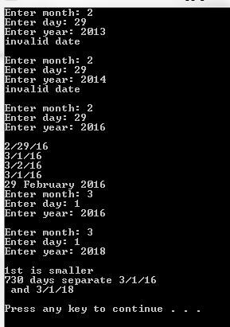

page 887 #8

 in addition to the operators defined on page 887, overload < and >

to do this you will first have to do page 802 #1

do not use 3 separate files, use only one.

use this as your main program

int main()  
{  
Date dd(1,1,2001);  
cin>>dd;  
dd.printslash();  
dd++;  
dd.printslash();  
++dd;  
dd.printslash();  
dd--;  
dd.printslash();  
--dd;  
dd.printday();  
Date dd2(1,1,2001);  
cin>>dd;  
cin>>dd2;  
if(dd>dd2)  
    cout<<"1st is bigger\n";  
if(dd<dd2)  
    cout<<"1st is smaller\n";  
cout<<dd-dd2<<" days separate "<<dd<<" and "<<dd2<<endl;  
system("pause");  
return 0;  
}

**extra credit**

Posted on: Tuesday, November 22, 2016 5:07:00 PM EST

due Sunday 12/18 7AM.  not HEC required--will be extra credit for HEC students too.

This project uses many of the topics we have learned this semester.

Write a program that reads a file, which contains grades for many students (at most 10).

each student has at least 3 lines of input

The first line of the file will have how many students there are

each student will follow

line 1 first and last name

line 2 GPA (0-4.0)     and number of credits completed      (will be this order)

line 3 number of courses currently enrolled in (max 5)

line 4-8    grade (A+,A,A-,B+,B,B-...F)         number of credits  (must be this order)

This data should be read into an array of structs.

Calculate each students GPA, after the new grades have been received

http://www.back2college.com/gpa.htm

Output will go to 2 files.

the first file will get the students name, and newly calculated GPA, as well as total credits completed, for all students

The 2nd file, will get the same information, but only for students with 63 or more credits (graduating students)

output to the screen the student/students with the highest GPA (validictorian)

all files, 1 input, 2 output, should ask the user for the file name. the input file name, should allow for errors in being entered.

use functions as much as possible

